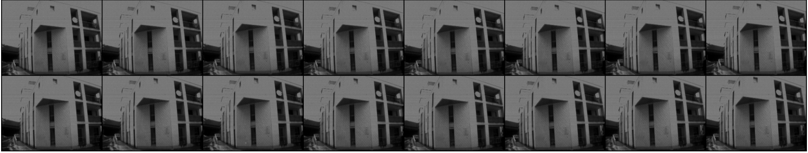

Fetch Event Size : 10000

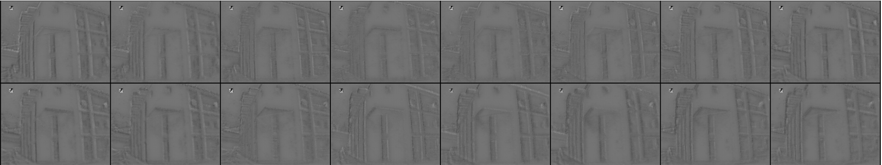

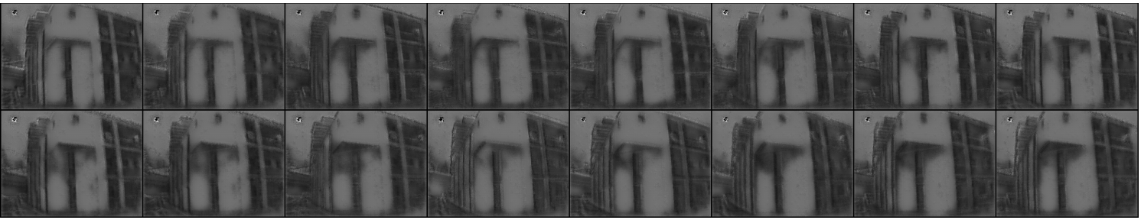

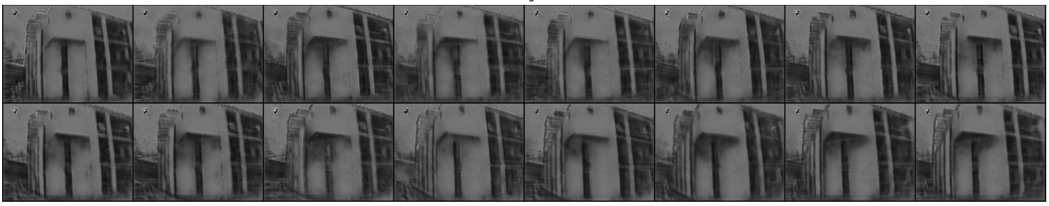

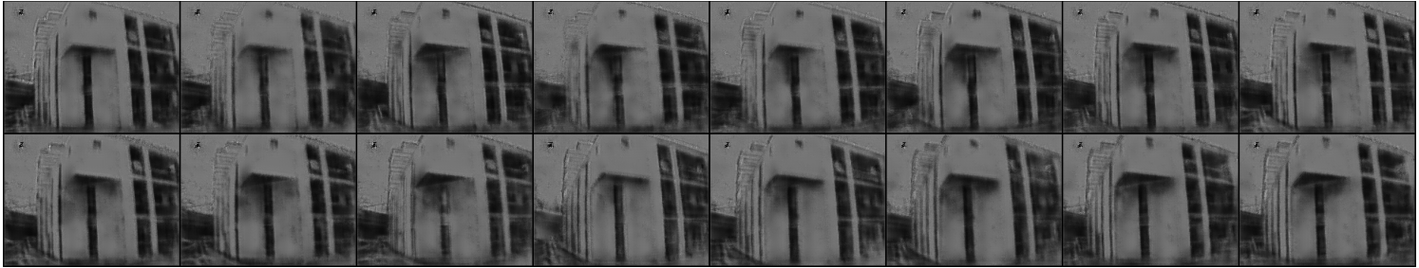

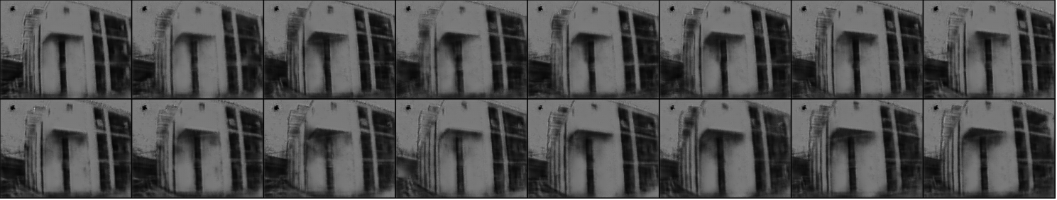

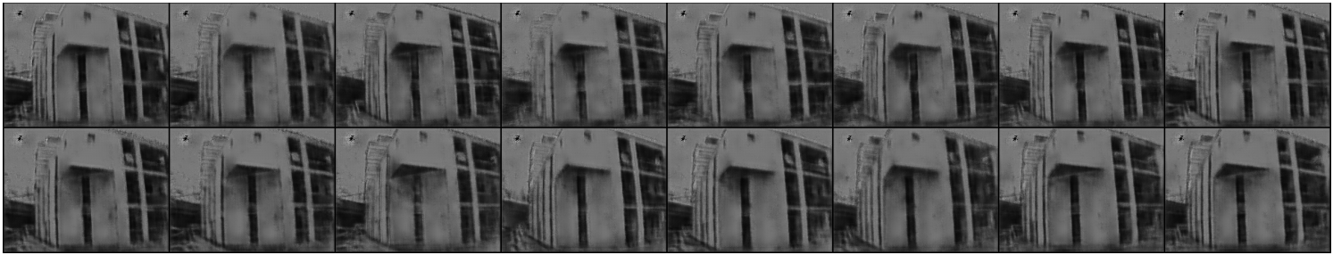

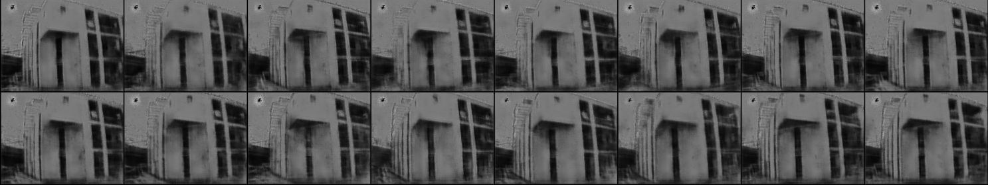

Event_size : 25000

